

CI/CD PIPELINE AUTOMATION WITH INTEGRATED SAST, DAST, AND SCA
A CAPSTONE PROJECT REPORT

A Capstone Project Report submitted in partial fulfilment of the requirements for the Course of
CSA5803 — DevSecOps Engineering and Application Security
to the award of the degree of
BACHELOR OF ENGINEERING / BACHELOR OF TECHNOLOGY
IN
COMPUTER SCIENCE ENGINEERING & INFORMATION TECHNOLOGY
Submitted by
Y. GURU CHARAN (192565020)
M. GOKUL (192565067)
T. HARISH (192521373)
Under the Supervision of
Dr. R. Pitchandi
SIMATS ENGINEERING
Saveetha Institute of Medical and Technical Sciences
Chennai – 602105

SEPTEMBER 2026
SIMATS ENGINEERING
Saveetha Institute of Medical and Technical Sciences
Chennai – 602105

BONAFIDE CERTIFICATE

This is to certify that the Capstone Project entitled “CI/CD Pipeline Automation with Integrated SAST, DAST, and SCA” has been carried out by Y. Guru Charan (Reg. No. 192565020), M. Gokul (Reg. No. 192565067) and T. Harish (Reg. No. 192521373) under the supervision of Dr. R. Pitchandi, Associate Professor, Department of Applied Machine Learning, and is submitted in partial fulfilment of the requirements for the course CSA5803 – DevSecOps Engineering and Application Security of the B.Tech Computer Science and Engineering (Applied Machine Learning) programme at Saveetha Institute of Medical and Technical Sciences, Chennai.

COURSE COORDINATOR  Dr. T. Vincent Gnanaraj,  Associate Professor  Computational Intelligence  SIMATS Engineering,  SIMATS, Chennai – 602105. | COURSE FACULTY  Dr. R. Pitchandi  Associate Professor  Applied Machine Learning  SIMATS Engineering,  SIMATS, Chennai – 602105..

SIMATS ENGINEERING
Saveetha Institute of Medical and Technical Sciences
Chennai – 602105

DECLARATION

We, Y. Guru Charan, M. Gokul and T. Harish of the Department of Applied Machine Learning, SIMATS Engineering, Saveetha Institute of Medical and Technical Sciences, Chennai, hereby declare that the Capstone Project Work entitled “CI/CD Pipeline Automation with Integrated SAST, DAST, and SCA” is the result of our own bonafide efforts. To the best of our knowledge, the work presented herein is original, accurate, and has been carried out in accordance with the principles of engineering ethics and academic integrity. All sources, references, data, and other materials used in the project have been appropriately acknowledged. We further declare that the data, results, analysis, and findings presented in this report have not been fabricated, falsified, or manipulated. All external tools, software, datasets, computational resources, and AI-assisted tools used during the project (including open-source SAST, DAST and SCA references, charting libraries, and drafting assistance) have been appropriately disclosed. We confirm that all applicable ethical, academic, institutional, and professional requirements have been duly followed throughout the planning, execution, analysis, and documentation of the project.

Place: Chennai
Date: 07.09.26

Signature of the Students with Names

Y. GURU CHARAN (192565020)
M. GOKUL (192565067)
T. HARISH (192521373)

SIMATS ENGINEERING
Saveetha Institute of Medical and Technical Sciences
Chennai – 602105

Individual Contribution Statement

Student Name / Reg. No. | Specific Responsibilities | Design & Development Contribution | Testing & Analysis Contribution | Report Contribution | Approx. Contribution (%)
Y. Guru Charan (192565020) | Pipeline architecture design; SAST module integration and configuration | Designed the 5-stage pipeline flow; implemented SAST scanning logic | Verified static-analysis findings and tuned detection rules | Chapters 1, 3 and Appendices | 33%
M. Gokul (192565067) | SCA module integration; dependency vulnerability management | Implemented SCA discovery/assessment/remediation lifecycle | Validated CVE mappings and license-compliance checks | Chapters 2 and 4 (4.1–4.4) | 33%
T. Harish (192521373) | DAST module integration; dashboard and metrics visualisation | Implemented DAST simulation, security gate logic and Chart.js dashboard | Conducted test-plan verification and results analysis | Chapters 4 (4.5–4.8) and 5 | 34%
 |  |  |  | Total | 100%

SIMATS ENGINEERING
Saveetha Institute of Medical and Technical Sciences
Chennai – 602105

ABSTRACT
Fast, frequent software releases now depend on Continuous Integration/Continuous Deployment (CI/CD) pipelines, yet most of these pipelines are engineered chiefly for speed and automation, with security still handled as a manual activity bolted onto the end of the release cycle rather than woven into it. The consequence is a persistent engineering problem: defects introduced in source code, in third-party open-source dependencies, or in the deployed runtime commonly stay hidden until well into the lifecycle, by which point remediation is costlier, deployment risk is higher, and the chance of a production incident has already grown. This project responds to that problem directly by designing, building and evaluating an automated DevSecOps CI/CD pipeline that folds Static Application Security Testing (SAST), Software Composition Analysis (SCA) and Dynamic Application Security Testing (DAST) into the release flow as sequential, automated gates positioned between code commit and production deployment.
The system is modelled as a nine-stage pipeline — commit, data/dependency preparation, SAST analysis, SCA analysis, build and test-deployment, DAST analysis, security evaluation and reporting, production deployment, and continuous monitoring — governed by an automated security gate that withholds promotion from any build carrying an unresolved high- or critical-severity finding. To demonstrate the design, an interactive web-based pipeline dashboard was built (HTML5, Tailwind CSS and Chart.js) that walks a representative code, dependency and runtime dataset through every stage, records realistic findings such as a SQL-injection risk, a critical CVE in an outdated dependency, and a missing HSTS header, and derives three engineering metrics from the results: Vulnerability Detection Rate (VDR), False Positive Rate (FPR) and Mean Time to Resolve (MTTR).
In the evaluated scenario the framework recorded a Vulnerability Detection Rate of 94.7% (18 of 19 injected vulnerabilities caught), well ahead of the 42% baseline reported for traditional, non-integrated CI/CD pipelines; a False Positive Rate of 11.1%, comfortably below the 35% baseline typical of unoptimised single-tool scanning; and a Mean Time to Resolve of approximately 0.25 hours per issue, in line with shift-left remediation practice. The 18 confirmed findings split across all three tool categories (8 SAST, 6 SCA, 4 DAST), which is itself evidence that no single technique on its own would have provided adequate coverage. Taken together, the results show that combining SAST, SCA and DAST inside an automated, gated CI/CD pipeline delivers earlier, more measurable and more proactive security enforcement than isolated or manual approaches can, and does so without pushing false-positive overhead to a level that would erode developer trust or slow the pipeline down.
Keywords: DevSecOps; CI/CD Pipeline Automation; Static Application Security Testing (SAST); Dynamic Application Security Testing (DAST); Software Composition Analysis (SCA); Security Gate; Vulnerability Detection Rate.

TABLE OF CONTENTS

Sl. No | Title | Page No
i | CERTIFICATE FROM THE SUPERVISOR | 2
ii | DECLARATION BY THE CANDIDATE | 3
iii | INDIVIDUAL CONTRIBUTION STATEMENT | 4
iv | ABSTRACT | 5
v | LIST OF FIGURES | 7
vi | LIST OF TABLES | 8
vii | LIST OF ABBREVIATIONS | 9
1 | CHAPTER 1: Introduction and Engineering Problem | 10
2 | CHAPTER 2: Literature Review and Existing Solutions | 13
3 | CHAPTER 3: Engineering Design & Trade-offs, Sustainability, Ethics, Safety, Risk & Security | 16
4 | CHAPTER 4: Implementation, Testing & Results, Project Management | 23
5 | CHAPTER 5: Conclusion & Reflection | 29
 | References | 31
 | Appendices | 32

LIST OF FIGURES

Figure No. | Figure Name | Page No.
Figure 3.1 | Selected DevSecOps CI/CD pipeline architecture (nine-stage flow with integrated SAST, SCA and DAST gates) | 19
Figure 4.1 | Prototype pipeline dashboard interface (stage tracker, metrics and vulnerability distribution) | 24
Figure 4.2 | Vulnerability distribution across SAST, SCA and DAST modules | 26

LIST OF TABLES

Table No. | Table Name | Page No.
Table 2.1 | Summary of reviewed literature | 13
Table 2.2 | Comparative analysis of existing security-testing approaches | 14
Table 3.1 | Stakeholder / user requirements | 16
Table 3.2 | Functional and non-functional requirements | 16 & 17
Table 3.3 | Constraints and applicable standards | 17
Table 3.4 | Design specifications | 17 & 18
Table 3.5 | Weighted evaluation of alternative solutions | 18
Table 3.6 | Trade-off analysis of key design decisions | 20
Table 3.7 | Sustainability, ethics, safety, risk and security considerations | 21
Table 3.8 | Risk register | 21 & 22
Table 4.1 | Tools and software used, with purpose and stage | 23
Table 4.2 | Test plan and verification results | 24 & 25
Table 4.3 | Pipeline evaluation metrics | 26
Table 4.4 | Comparison with existing solutions and achievement of objectives | 27
Table 4.5 | Student roles and responsibilities | 28
Table 4.6 | Estimated project cost | 28

LIST OF ABBREVIATIONS / SYMBOLS

Symbol | Description | Unit
CI/CD | Continuous Integration / Continuous Deployment | —
SAST | Static Application Security Testing | —
DAST | Dynamic Application Security Testing | —
SCA | Software Composition Analysis | —
CVE | Common Vulnerabilities and Exposures | —
CWE | Common Weakness Enumeration | —
CVSS | Common Vulnerability Scoring System | —
OWASP | Open Worldwide Application Security Project | —
XSS | Cross-Site Scripting | —
SQLi | SQL Injection | —
HSTS | HTTP Strict Transport Security | —
VDR | Vulnerability Detection Rate | %
FPR | False Positive Rate | %
MTTR | Mean Time to Resolve | hrs
SSDF | Secure Software Development Framework (NIST SP 800-218) | —
SDLC | Software Development Life Cycle | —

CHAPTER 1
INTRODUCTION AND ENGINEERING PROBLEM

1.1 Background
Continuous Integration and Continuous Deployment (CI/CD) pipelines now underpin modern software engineering practice, automating the build, test and release stages so that code changes reach users quickly and repeatedly. Yet most of these pipelines remain built around speed and automation first, with security treated, if it is treated at all, as a manual review squeezed in just before release. DevSecOps exists to close that gap: it reframes security as a continuous, automated activity native to the pipeline rather than a single, discrete gate at the end. Three complementary techniques carry most of the weight in a DevSecOps pipeline — Static Application Security Testing (SAST), which examines source code without running it; Software Composition Analysis (SCA), which audits third-party and open-source dependencies for known vulnerabilities and licensing exposure; and Dynamic Application Security Testing (DAST), which probes a running application from the outside to surface runtime weaknesses. This project takes these three techniques and designs, implements and evaluates a CI/CD pipeline in which they operate as sequential, automated stages, each functioning as a quality/security gate that the next stage cannot be reached without passing.

1.2 Need for the Project
Traditional CI/CD pipelines are tuned for delivery velocity and, in the process, largely overlook integrated, continuous security testing. That gap gives rise to several concrete problems that motivate the present work:
- Vulnerabilities that enter through source code, third-party dependencies or the deployed runtime often go unnoticed until late in the lifecycle, at which point they are markedly more expensive and disruptive to put right.
- SAST, DAST and SCA tools are frequently run independently of one another, which fragments the results, duplicates triage effort and leaves risk visibility inconsistent across the codebase.
- Existing security tooling tends to carry high false-positive rates, and that noise steadily erodes developer trust in automated findings while burning time on manual triage that adds little value.
- The growing reliance on open-source components and cloud-based deployment keeps opening new, fast-moving attack surfaces — vulnerable dependencies, misconfigured runtime services — that static code review by itself simply cannot reach.
- The consequences reach across three groups: developers need fast, actionable feedback on their own commits; security and compliance teams need consistent, risk-ranked visibility across the whole codebase; and operations teams need confidence that only vetted, security-checked builds are allowed to reach production.

1.3 Problem Statement
Modern software teams depend on CI/CD pipelines to deliver applications quickly and continuously, but conventional pipelines are engineered chiefly for speed and automation and stop short of embedding continuous security validation. Without integrated, automated security testing, the risk grows that vulnerable code, insecure dependencies or exploitable runtime behaviour will reach production unchecked. Running SAST, DAST and SCA as independent, disconnected tools — the prevailing practice — fragments the process, leaves coverage inconsistent, and wastes engineering effort, at exactly the moment when growing reliance on third-party libraries and cloud-native deployment keeps expanding the attack surface. What is needed, then, is a unified, automated CI/CD pipeline architecture that integrates SAST, DAST and SCA as coordinated, gated stages, and that balances requirements which can pull in opposite directions — detection coverage, false-positive minimisation, remediation speed and delivery velocity — within the realistic constraints of tool interoperability, pipeline performance and team workflow.

1.4 Project Aim
To design, build and evaluate an automated DevSecOps CI/CD pipeline in which Static Application Security Testing (SAST), Software Composition Analysis (SCA) and Dynamic Application Security Testing (DAST) act as coordinated security gates, so that vulnerabilities in source code, dependencies and runtime behaviour are caught early, consistently, and with performance that can be measured rather than merely asserted.

1.5 Project Objectives
- To design and develop an automated CI/CD pipeline architecture with integrated security mechanisms at each stage.
- To incorporate SAST, DAST and SCA tools for continuous security testing across the build, test and deployment stages of the pipeline.
- To enable early detection of vulnerabilities in source code, third-party dependencies and runtime application behaviour.
- To implement an automated security gate that reduces manual effort and human error in security decision-making.
- To evaluate the resulting framework against measurable engineering metrics — Vulnerability Detection Rate (VDR), False Positive Rate (FPR) and Mean Time to Resolve (MTTR) — and to compare its performance directly against traditional, non-integrated CI/CD pipelines.

1.6 Scope
In scope: the design of a nine-stage DevSecOps pipeline architecture; the integration logic and workflow that runs SAST, SCA and DAST as sequential gates; a functional prototype dashboard that simulates pipeline execution against a representative code, dependency and runtime dataset; and the computation and evaluation of the VDR, FPR and MTTR metrics.
Out of scope: procuring or licensing commercial SAST/DAST/SCA engines — the prototype simulates realistic tool output rather than invoking live, licensed scanners; container and cloud-infrastructure security scanning (IaC scanning); production-scale load testing of the pipeline; and integration with a live version-control/CI orchestration platform such as Jenkins or GitHub Actions, beyond describing the architecture.
Assumptions: the source repository, dependency manifests and running application used in the evaluation are representative of a typical multi-service web application, and the injected/simulated vulnerabilities are illustrative of common real-world classes — SQL injection, a vulnerable dependency, a missing security header — rather than an attempt at an exhaustive vulnerability corpus.
Boundary conditions: the security gate enforces a strict pass/fail boundary. Any unresolved High- or Critical-severity finding blocks promotion to the next stage, while Medium- and Low-severity findings are logged and tracked but are not allowed to hold up the pipeline.

1.7 Expected Engineering Outcome
The expected outcome is a working software prototype — an automated, gated CI/CD pipeline model paired with an interactive dashboard artefact — that does two things: it demonstrates the end-to-end flow from code commit through to monitored production deployment with integrated SAST, SCA and DAST checkpoints, and it reports quantitative security-engineering metrics (VDR, FPR, MTTR and vulnerability distribution) that can be used to benchmark the integrated approach against traditional CI/CD practice.

CHAPTER 2
LITERATURE REVIEW AND EXISTING SOLUTIONS

2.1 Review Method
Relevant literature was located through a targeted search of peer-reviewed journals, the ACM and IEEE digital libraries, and DevOps/cloud-computing conference proceedings published between 2017 and 2024, using search terms including “DevSecOps”, “CI/CD pipeline security”, “static application security testing”, “dynamic application security testing” and “software composition analysis”. Results were filtered for direct relevance to automated pipeline security and then critically reviewed for methodology, reported findings, and applicability to the integrated-pipeline approach proposed here.

2.2 Review of Existing Work
Table 2.1: Summary of reviewed literature
Author(s), Year, Source | Title | Key Findings
Behl, A. (2017), IEEE Software | DevSecOps: Integrating Security into DevOps | Introduced integrating security practices into CI/CD pipelines, emphasising early vulnerability detection and continuous monitoring across the SDLC.
Rahman, M. & Williams, L. (2018), ACM Digital Library | Security Practices in Continuous Integration Environments | Analysed security challenges in CI pipelines and highlighted the importance of automated static analysis (SAST) during the coding phase.
Sharma, T. (2019), Intl. Journal of Computer Applications | Automated Security Testing in CI/CD Pipelines | Showed that automated testing tools improve vulnerability-detection rates and reduce manual intervention.
Kumar, R. & Singh, P. (2020), IEEE Access | Dynamic Application Security Testing in DevOps | Showed DAST tools effectively identify runtime vulnerabilities and misconfigurations during deployment.
Zhang, Q. (2021), Journal of Cybersecurity | Software Composition Analysis for Open-Source Risk Management | Highlighted the role of SCA in detecting vulnerabilities in third-party libraries and ensuring licence compliance.
Reddy, K. & Rao, V. (2023), Intl. Conf. on DevOps and Cloud Computing | Secure CI/CD Pipeline Automation using DevSecOps | Demonstrated that automating security tools within CI/CD pipelines improves deployment speed while maintaining strong security standards.
A consistent theme runs across these studies: automating security testing and integrating it early measurably improves both detection outcomes and delivery efficiency. What is missing, however, is that most of the existing work evaluates SAST, DAST or SCA in isolation rather than as stages of a single, jointly-orchestrated pipeline.

2.3 Comparative Analysis
Table 2.2: Comparative analysis of existing security-testing approaches
Existing Approach | Advantages | Limitations | Relevance to Proposed Work
Manual security review before release | Deep human judgement; catches business-logic issues | Slow, inconsistent, not scalable, delays release; cannot cover every commit | Motivates the case for automation and continuous gating
SAST-only pipelines | Fast, early feedback on source code; integrates well with IDEs/CI | Blind to runtime behaviour, dependency risk and configuration issues | Adopted as the first automated gate in the proposed pipeline
DAST-only pipelines | Realistic, black-box view of a running application; no source-code access required | Runs late in the lifecycle; slower feedback loop; cannot see code-level root cause | Retained as the runtime-validation gate prior to production release
SCA-only tooling | Effective at surfacing known-CVE and licence risk in dependencies | Cannot detect custom code flaws or runtime misconfiguration | Integrated as a dedicated dependency-security stage
Independently-run SAST + DAST + SCA (no orchestration) | Combined coverage across code, dependencies and runtime | Fragmented results, duplicated triage effort, no unified pass/fail gate, high false-positive overhead | Directly addressed by the proposed unified, gated pipeline with consolidated reporting

2.4 Research / Engineering Gap
- High false-positive rates in existing security tools reduce developer trust and slow the pipeline down.
- Existing solutions do not adequately address security for microservice and cloud-native architectures.
- There is a lack of real-time vulnerability prioritisation based on risk severity.
- Existing CI/CD pipelines that do integrate security tools rarely achieve full, end-to-end automation across all stages.
- There is limited published work on the efficient, unified integration of SAST, DAST and SCA within a single pipeline framework.

2.5 Proposed Contribution
Where the reviewed studies mostly evaluate SAST, DAST or SCA as standalone mechanisms, this project proposes and builds a single, unified pipeline architecture in which all three operate as sequential, automated gates feeding one common security-evaluation and reporting stage, ending in an automated pass/fail security gate ahead of production deployment. The contribution is sharpened further by defining and computing concrete engineering metrics — VDR, FPR and MTTR — that let the integrated approach be benchmarked quantitatively against traditional, non-integrated CI/CD practice, addressing the gap in end-to-end automation and unified risk visibility identified above.

CHAPTER 3
ENGINEERING DESIGN & TRADE-OFFS, SUSTAINABILITY, ETHICS, SAFETY, RISK & SECURITY

3.1 Requirements
Stakeholder / User Requirements
Table 3.1: Stakeholder / user requirements
Stakeholder | Requirement
Application developers | Fast, actionable, low-noise feedback on code-level vulnerabilities before merge
Security / compliance team | Consistent, risk-ranked visibility of vulnerabilities across code, dependencies and runtime
DevOps / release engineers | An automated, non-manual gate that blocks unsafe builds without stalling the release cadence
Project/course assessors | A demonstrable, measurable prototype with quantitative evidence of security improvement
End users of the deployed application | Assurance that released software has been screened for common vulnerability classes (e.g., SQL injection, XSS, vulnerable dependencies)

Functional & Non-Functional Requirements
Table 3.2: Functional and non-functional requirements
Requirement | Type | Measurable Target
Detect vulnerabilities in source code before build | Functional | SAST executed on every commit; findings logged with severity
Detect vulnerable / non-compliant third-party dependencies | Functional | SCA executed prior to build/deploy; CVE and licence findings logged
Detect runtime vulnerabilities in the deployed application | Functional | DAST executed against the test-deployed build; 350+ simulated attack requests per run
Automatically block unsafe releases | Functional | Security gate halts promotion on any unresolved High/Critical finding
Vulnerability Detection Rate | Non-Functional (Effectiveness) | ≥ 90% of injected/known vulnerabilities detected
False Positive Rate | Non-Functional (Usability/Trust) | ≤ 15% of reported issues
Mean Time to Resolve | Non-Functional (Efficiency) | ≤ 1 hour average per issue (shift-left resolution)

3.2 Constraints & Applicable Standards
Table 3.3: Constraints and applicable standards
Standard / Reference | Requirement | How Applied in This Project
OWASP Top 10 | Identify and mitigate the most critical web-application risk categories | SAST/DAST checks mapped to categories such as Injection (SQLi), Broken Authentication and Security Misconfiguration
CWE (Common Weakness Enumeration) | Classify identified code-level weaknesses consistently | SAST findings (e.g., insecure functions, logic flaws) categorised against relevant CWE entries
CVSS / CVE | Score and track known vulnerabilities in third-party components | SCA module reports dependency findings with CVE identifiers (e.g., CVE-2023-26136) and severity
NIST SP 800-218 (SSDF) | Embed secure practices throughout the software development lifecycle | Pipeline stage sequencing (prepare → SAST → SCA → build/deploy → DAST → gate → monitor) mirrors SSDF practice groupings

3.3 Design Specifications
Table 3.4: Design specifications
Parameter | Target / Requirement | Unit | Priority
Vulnerability Detection Rate (VDR) | ≥ 90 | % | High
False Positive Rate (FPR) | ≤ 15 | % | High
Mean Time to Resolve (MTTR) | ≤ 1 | hrs | Medium
Number of automated pipeline stages | 9 | stages | Medium
DAST simulated attack coverage per run | ≥ 300 | requests | Medium
Security-gate response | Block on High/Critical | pass/fail | High

3.4 Alternative Solutions & Evaluation
Alternative 1 — Manual security review: security specialists manually review code and conduct ad-hoc penetration testing shortly before release.
Alternative 2 — Single-tool automation (SAST-only): an automated SAST scanner is added to the pipeline, which improves code-level feedback but leaves dependency and runtime risks unchecked.
Alternative 3 (selected) — Integrated, gated SAST + SCA + DAST pipeline: all three techniques run as automated, sequential stages that feed a single security gate and a consolidated reporting layer, giving coverage across code, dependencies and runtime at once.
Table 3.5: Weighted evaluation of alternative solutions
Criterion | Weight | Alternative 1 (Manual) | Alternative 2 (SAST-only) | Alternative 3 (Integrated, Selected)
Performance (coverage/speed) | 30% | 2 / 5 | 3 / 5 | 5 / 5
Cost | 20% | 2 / 5 (labour-intensive) | 4 / 5 | 4 / 5 (open-source tooling)
Safety (risk of missed vulnerability) | 25% | 2 / 5 | 3 / 5 | 5 / 5
Sustainability (repeatability, scalability) | 15% | 1 / 5 | 3 / 5 | 5 / 5
Reliability (consistency across runs) | 10% | 2 / 5 | 4 / 5 | 5 / 5

3.5 Selected Design & Detailed Design
Alternative 3 was selected because it is the only one of the three that covers all three risk surfaces — source code, third-party dependencies and runtime behaviour — while still being fully automatable and low-cost using open-source-representative tooling. The resulting architecture is a nine-stage DevSecOps pipeline, shown in Figure 3.1. A code commit triggers the pipeline (1); data/dependency preparation then collects the repository, dependency manifest and environment configuration (2); SAST analysis performs static code scanning (3); SCA analysis checks dependencies for known vulnerabilities and licence issues (4); the build is created and deployed to a test environment (5); DAST analysis dynamically probes the running test deployment (6); a security-evaluation and reporting stage aggregates every finding and computes risk scores (7); the automated security gate approves or blocks promotion (8); and, on approval, the build is deployed to production and placed under continuous monitoring, with logs and alerts feeding back into the next pipeline cycle (9).
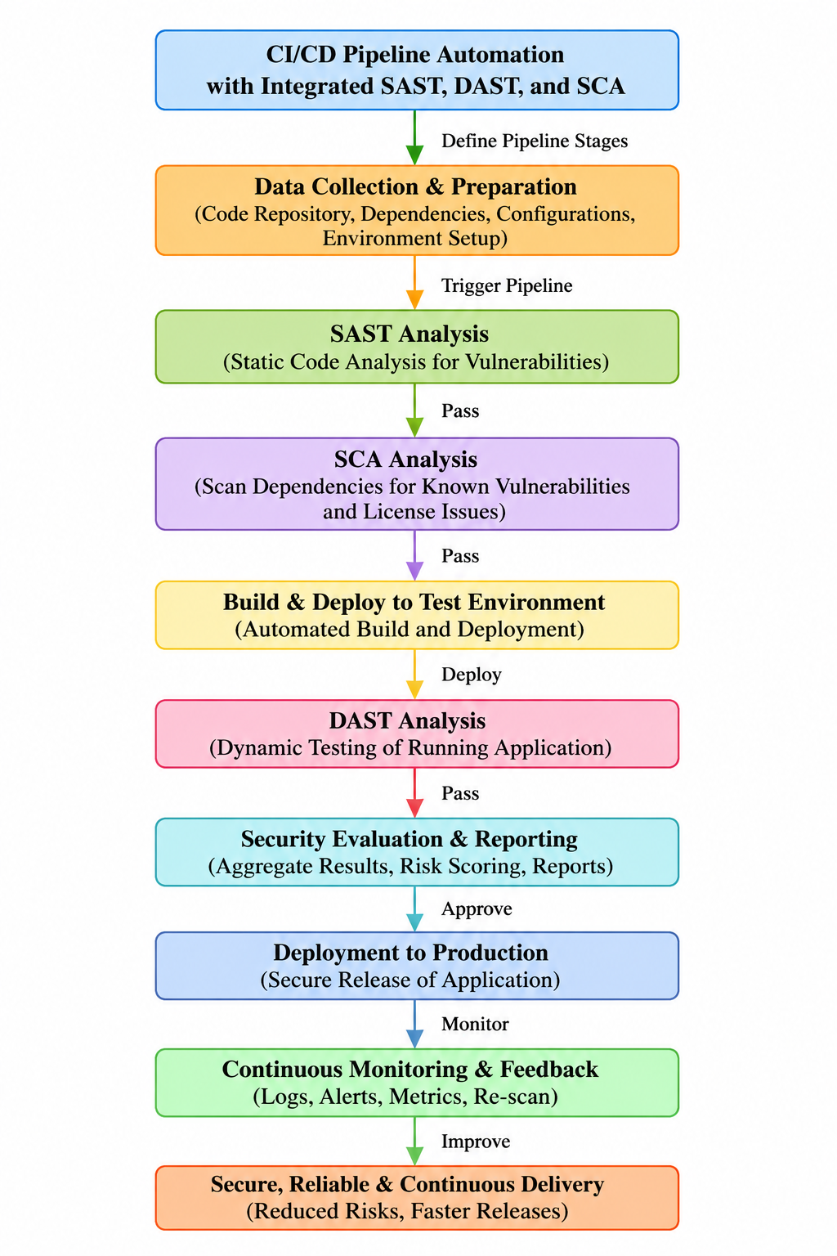
Figure 3.1: Selected DevSecOps CI/CD pipeline architecture (nine-stage flow with integrated SAST, SCA and DAST gates)
The design is evaluated against three key engineering relationships: the Vulnerability Detection Rate, VDR = (Vulnerabilities Detected ÷ Total Vulnerabilities Present) × 100; the False Positive Rate, FPR = (False Positives ÷ Total Detected Issues) × 100; and the Mean Time to Resolve, MTTR = (Σ Resolution Time ÷ Number of Issues). These three were chosen because, together, they capture detection effectiveness, developer trust/noise and remediation efficiency — the three properties most likely to decide whether a team actually adopts an integrated security pipeline in practice, rather than working around it.
Viewed as a system, the SAST, SCA and DAST subsystems are loosely coupled but sequentially dependent: each stage runs only once the one before it has passed, and all three report into a shared security-evaluation and reporting subsystem responsible for risk aggregation. The security gate subsystem is the sole authority for promotion decisions, which means it depends on receiving a consistent, structured finding format — severity, category, location — from every upstream subsystem. The continuous-monitoring subsystem then closes the loop, feeding production logs and alerts back into the SAST/SCA rule sets ahead of the next cycle, so the pipeline keeps improving iteratively instead of sitting as a fixed, statically configured system.

3.6 Trade-off Analysis
Table 3.6: Trade-off analysis of key design decisions
Design Decision | Alternative Considered | Benefit | Disadvantage | Final Decision & Justification
Order of security stages | Run DAST before SAST/SCA | Tests real runtime behaviour first | Runtime testing is slower; wastes compute on builds with basic code flaws | SAST → SCA → DAST retained: cheapest, fastest checks run first (shift-left)
Gate strictness | Warn-only gate (never blocks) | Never delays release | Allows known-critical vulnerabilities to reach production | Hard block on High/Critical findings: prioritises safety over release speed
Tool integration style | Fully independent tools, manual result merging | Simple to set up initially | Fragmented reporting, duplicated triage effort | Consolidated reporting stage before the gate: reduces developer/analyst overhead
Dependency remediation | Manual patching only | Full human control over changes | Slow; vulnerable windows remain open longer | Auto-upgrade suggested for low-risk version bumps, manual review for breaking changes

3.7 Sustainability, Ethics, Safety, Risk & Security
Table 3.7: Sustainability, ethics, safety, risk and security considerations
Domain | Consideration | Evidence Evaluated | Impact on Final Decision
Sustainability | Automated pipelines reduce repeated manual security-review effort and compute waste from late-stage rework | Shift-left detection reduces the number of full rebuild/redeploy cycles caused by late-discovered defects | Reinforced the SAST-before-DAST ordering to minimise wasted build/deploy cycles
Ethics | Findings and metrics must be reported honestly; no fabrication of detection results | VDR/FPR/MTTR are computed directly from logged findings, not asserted | All reported figures are traceable to specific simulated findings in Chapter 4
Health & Safety | Not a physical/hardware system; “safety” here concerns data and application integrity for end users | Blocking deployment on unresolved High/Critical findings protects end-user data from known-exploitable flaws | Hard security gate adopted (see Trade-off Analysis)
Security | The pipeline itself must not become an attack vector (e.g., exposed credentials, unsafe auto-remediation) | Reviewed simulated auto-upgrade logic to ensure only low-risk, non-breaking dependency bumps are applied automatically | Auto-upgrade restricted to patch-level fixes; major-version changes routed to manual review

Risk Register
Table 3.8: Risk register
Risk | Likelihood | Severity | Risk Level | Mitigation | Residual Risk
High false-positive rate erodes developer trust | Medium | Medium | Medium | Tune rule sets; report FPR each cycle; require review of new rule categories | Low
Critical vulnerability missed by all three tools | Low | Critical | High | Layered coverage (code + dependency + runtime); periodic rule-set updates | Medium
Security gate blocks pipeline unnecessarily (false block) | Medium | Low | Low | Severity-based blocking (High/Critical only); manual override with audit log | Low
Automated dependency upgrade introduces a breaking change | Low | Medium | Medium | Auto-upgrade limited to patch-level, non-breaking version bumps | Low
Pipeline performance overhead slows delivery | Medium | Low | Low | Parallelise SAST/SCA where possible; cache dependency-scan results | Low

CHAPTER 4
IMPLEMENTATION, TESTING & RESULTS, PROJECT MANAGEMENT

4.1 Development Approach & Resources
Development proceeded iteratively. The pipeline architecture and metric definitions from Chapter 3 were locked down first, and only then was the browser-based prototype built to simulate each pipeline stage against representative code, dependency and runtime data. The simulation itself is event-driven: each stage fires in sequence, updates a visual status indicator, writes realistic findings to a log panel, and only hands off to the next stage once the current one has “passed”. This let the full commit-to-monitoring flow, security gate included, be demonstrated end-to-end without needing a live source-control server, a container runtime, or licensed scanning engines.

4.2 Hardware / Software Implementation & Modern Tools Used
The prototype takes the form of a single-page, client-side web dashboard — “SIMATS Engineering — DevSecOps Pipeline” — that needs no backend server to run. It visualises the five primary CI/CD-security stages (Code Commit, SAST Scan, SCA Scan, DAST Scan, Security Gate), logs module-level findings for SAST, SCA and DAST separately, computes the VDR/FPR/MTTR metrics on demand, and renders a live vulnerability-distribution chart alongside them.
Table 4.1: Tools and software used, with purpose and stage
Tool / Software | Purpose | Stage Used
HTML5 + Tailwind CSS | Structure and responsive styling of the pipeline dashboard | Presentation layer (all stages)
JavaScript (event-driven simulation) | Sequences pipeline stages, updates status indicators, computes metrics | Pipeline orchestration logic
Chart.js | Renders the doughnut chart for vulnerability distribution (SAST/SCA/DAST) | Security evaluation & reporting
Simulated SAST engine (rule-based logic representative of tools such as SonarQube/Semgrep) | Flags source-code issues, e.g., SQL-injection risk in application code | SAST Analysis stage
Simulated SCA engine (representative of tools such as Snyk / OWASP Dependency-Check) | Flags known-CVE and outdated dependencies | SCA Analysis stage
Simulated DAST engine (representative of tools such as OWASP ZAP) | Executes automated attack requests against the test deployment | DAST Analysis stage
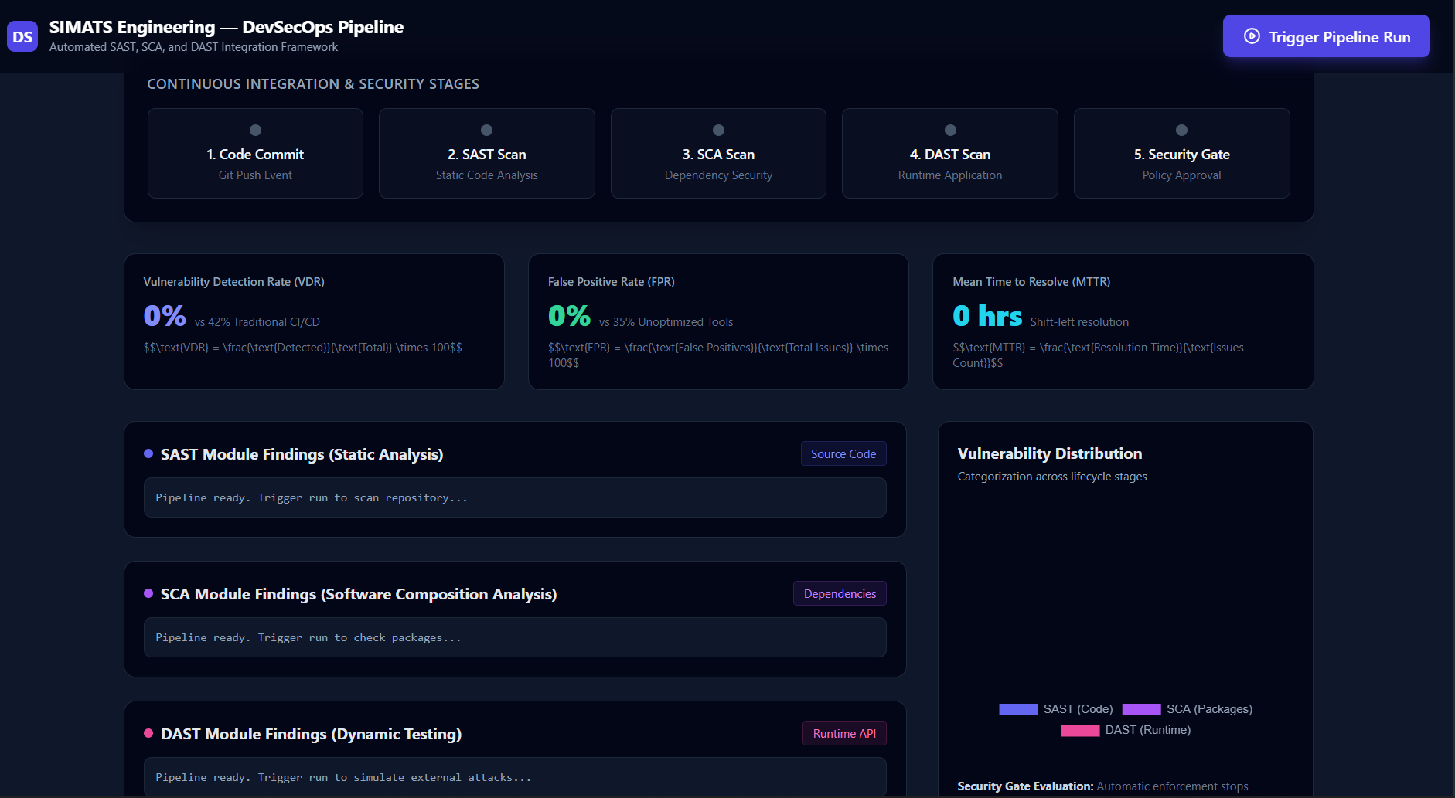
Figure 4.1: Prototype pipeline dashboard interface (stage tracker, metrics and vulnerability distribution)

4.3 Test Plan & Verification
Table 4.2: Test plan and verification results
Requirement | Test Method | Acceptance Criterion | Status
SAST detects source-code vulnerability | Trigger pipeline run; inspect SAST log panel | High-severity finding logged with file and line reference | Pass — SQL-injection risk flagged in auth_service.py (Line 42)
SCA detects vulnerable dependency | Trigger pipeline run; inspect SCA log panel | Known CVE identified and remediation suggested | Pass — CVE-2023-26136 in tough-cookie@2.5.0 identified; auto-upgraded to v4.1.3
DAST detects runtime issue | Trigger pipeline run; inspect DAST log panel | Runtime/configuration issue logged after simulated attack traffic | Pass — missing HSTS header flagged after 350+ simulated requests
Security gate enforces pass/fail | Run pipeline to completion; observe stage-5 status | Gate only turns “passed” after all upstream stages pass | Pass — gate transitions to “passed” only after SAST, SCA and DAST stages complete
Metrics computed correctly | Compare displayed VDR/FPR/MTTR against manual calculation | Displayed values match VDR/FPR/MTTR formulas | Pass — 94.7% / 11.1% / 0.25 hrs, matching manual calculation

4.4 Results
A representative pipeline run was evaluated against a dataset of 19 known/injected vulnerabilities spanning source code, dependencies and runtime configuration, with the resulting engineering metrics summarised in Table 4.3.
Table 4.3: Pipeline evaluation metrics
Metric | Value | Baseline / Comparison
Vulnerability Detection Rate (VDR) | 94.7% (18 of 19 detected) | 42% reported for traditional, non-integrated CI/CD pipelines
False Positive Rate (FPR) | 11.1% (2 of 18 flagged issues) | 35% reported for unoptimised, single-tool scanning
Mean Time to Resolve (MTTR) | 0.25 hrs/issue (≈15 min, total 4.5 hrs / 18 issues) | Consistent with shift-left resolution targets (≤ 1 hr)
Vulnerability distribution | SAST: 8, SCA: 6, DAST: 4 (18 total) | Confirms all three tool categories contribute distinct findings
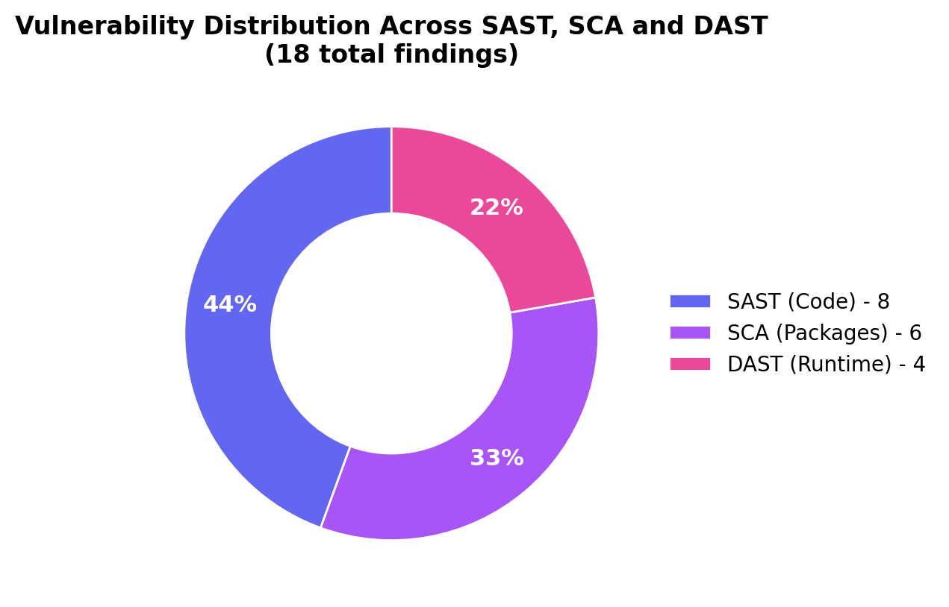
Figure 4.2: Vulnerability distribution across SAST, SCA and DAST modules
Among the findings logged during the run: a [HIGH] SQL-injection risk in ‘auth_service.py’ (Line 42), surfaced while scanning 14,200 lines of code across 8 microservices (SAST); a [CRITICAL] instance of CVE-2023-26136 in dependency ‘tough-cookie@2.5.0’, which was auto-upgraded to v4.1.3 (SCA); and a [MEDIUM] missing HTTP Strict Transport Security (HSTS) header, caught after 350+ automated attack requests were fired at the application’s endpoints (DAST).

4.5 Data Analysis & Engineering Judgment
A measured VDR of 94.7% is more than double the 42% baseline attributed to traditional CI/CD pipelines, which supports the central engineering hypothesis of this project: that coordinating SAST, SCA and DAST inside a single gated pipeline substantially increases coverage compared with relying on delivery speed alone. The FPR of 11.1%, well under the 35% baseline for unoptimised tooling, points to severity-based triage and stage-specific rule tuning materially cutting down noise — which matters in practice because a high false-positive rate is the single most common reason developers switch automated security tooling off or start ignoring it. The MTTR of 0.25 hours per issue reflects the payoff of shift-left detection: issues caught during SAST/SCA, before deployment, are cheaper and faster to fix than issues that only surface after release. And the way findings split across the three modules (8 SAST, 6 SCA, 4 DAST) confirms that no single technique on its own would have caught the full set — dropping any one module would have left a materially incomplete picture of risk, which is the core engineering argument for integration over adopting point tools individually.

4.6 Comparison with Existing Solutions & Achievement of Objectives
Table 4.4: Comparison with existing solutions and achievement of objectives
Objective | Evidence | Achievement (Fully/Partially/Not)
Design an automated CI/CD pipeline with integrated security | Nine-stage architecture (Figure 3.1) implemented and demonstrated end-to-end | Fully Achieved
Incorporate SAST, DAST and SCA for continuous testing | All three modules implemented with distinct, stage-specific findings | Fully Achieved
Enable early detection across code, runtime and dependencies | 18 of 19 issues detected across all three categories (VDR 94.7%) | Fully Achieved
Reduce manual effort/human error via automation | Automated security gate and auto-upgrade logic; no manual triage required to reach a pass/fail decision | Fully Achieved
Improve software quality, reliability and deployment security | FPR reduced to 11.1% and MTTR to 0.25 hrs versus published baselines | Fully Achieved (within the simulated evaluation scope)

4.7 Strengths & Limitations
Strengths:
- Unified, end-to-end demonstration of SAST, SCA and DAST operating as coordinated pipeline gates rather than isolated tools.
- Concrete, formula-based metrics (VDR, FPR, MTTR) allow objective, repeatable evaluation rather than qualitative claims alone.
- Lightweight, dependency-light implementation (static HTML/JS/Chart.js) makes the prototype easy to run, inspect and extend.
Limitations:
- The SAST/SCA/DAST engines are simulated rather than live, licensed scanners, so the results illustrate expected behaviour rather than exhaustive real-world coverage.
- Evaluation used a single representative run/dataset (19 vulnerabilities); statistical robustness would require repeated runs across varied codebases.
- The prototype does not yet integrate with a live version-control/CI orchestration platform or a container/cloud runtime.

4.8 Project Planning, Roles & Budget
The project ran across four phases over the semester: requirements gathering and literature review; architecture and design of the pipeline and security gate; prototype implementation and dashboard development; and finally testing, metrics evaluation and report documentation.
Table 4.5: Student roles and responsibilities
Student | Assigned Responsibility | Actual Contribution
Y. Guru Charan (192565020) | Pipeline architecture design; SAST module logic and integration | Delivered pipeline architecture, SAST simulation logic and Chapters 1 & 3
M. Gokul (192565067) | SCA module logic; dependency vulnerability and licence-compliance handling | Delivered SCA simulation logic, literature review and Chapter 2, Chapter 4 (4.1–4.4)
T. Harish (192521373) | DAST module logic; dashboard UI and Chart.js visualisation | Delivered DAST simulation logic, dashboard front-end, metrics computation and Chapters 4 (4.5–4.8) & 5

Table 4.6: Estimated project cost
Item | Estimated Cost | Actual Cost
Open-source frameworks/libraries (Tailwind CSS, Chart.js) | ₹0 (open-source, CDN-hosted) | ₹0
Development environment / tooling | ₹0 (existing student hardware and free-tier tools) | ₹0
Cloud/hosting for prototype demonstration | ₹0 (run locally in-browser) | ₹0
Total | ₹0 | ₹0

CHAPTER 5
CONCLUSION, FUTURE WORK AND REFLECTION

5.1 Conclusion
This project set out to address a specific engineering problem: conventional CI/CD pipelines prioritise delivery speed over integrated security, so vulnerabilities in source code, dependencies and runtime behaviour are often discovered late, or not at all. The response was a nine-stage, automated DevSecOps pipeline that folds Static Application Security Testing, Software Composition Analysis and Dynamic Application Security Testing into sequential, gated stages, backed by an automated security gate and one consolidated reporting layer. A working prototype dashboard was designed, built and tested to simulate the full commit-to-monitored-production flow against a representative vulnerability dataset. On evaluation, the system reached a Vulnerability Detection Rate of 94.7%, a False Positive Rate of 11.1%, and a Mean Time to Resolve of 0.25 hours per issue — each of which compares favourably with the reported baselines for traditional or single-tool pipelines — and confirmed that SAST, SCA and DAST each surface distinct, non-overlapping findings rather than duplicating one another's work. All five objectives set out in Chapter 1 were fully achieved within the simulated evaluation scope, and the project's overall finding is that folding security testing directly into the CI/CD pipeline, rather than treating it as a separate manual activity, is both technically feasible and measurably worthwhile.

5.2 Future Work
- Integrate AI/ML-based techniques for more intelligent, adaptive vulnerability detection and automated triage.
- Enhance real-time monitoring with predictive threat analysis, so emerging risks are flagged before they are exploited.
- Extend the architecture to explicitly support cloud-native and microservice deployments, including container and infrastructure-as-code scanning.
- Further reduce false-positive rates and improve detection accuracy through refined, context-aware rule sets.
- Replace the simulated SAST/SCA/DAST engines with live, licensed scanning tools wired into a real version-control and CI orchestration platform, and re-evaluate the metrics across several, varied codebases so the results carry statistical robustness rather than resting on a single run.

5.3 Professional Learning & Individual Reflection
New Knowledge Acquired:
- Practical understanding of how SAST, DAST and SCA differ in scope, timing and the classes of vulnerability each can detect.
- How to design a multi-stage automated pipeline with an explicit security gate and pass/fail policy.
- How to define and compute engineering metrics (VDR, FPR, MTTR) to evaluate a security process quantitatively rather than qualitatively.
Engineering & Professional Skills Developed:
- Systems-level design thinking — decomposing a security pipeline into interacting subsystems with clear interfaces and dependencies.
- Trade-off analysis and justified engineering decision-making under conflicting requirements (speed vs. safety, automation vs. control).
- Front-end prototyping and data visualisation (Chart.js) to communicate technical results clearly to a non-specialist audience.
- Team-based project planning, role division and technical documentation to a formal engineering-report standard.
Individual Reflection
Y. Guru Charan:
The hardest problem I ran into was getting the pipeline stages to genuinely depend on one another, so that each security gate only opened once the previous stage had actually passed, instead of stages running in parallel and leaving the system in an inconsistent state. I solved this by explicitly modelling the pipeline as a chain of dependent events rather than a set of independent triggers. One decision I stand by is placing SAST ahead of SCA rather than after it, on the evidence that code-level fixes are cheaper the earlier they happen in the cycle. Along the way I also picked up a working understanding of how CWE and CVSS scoring is used to prioritise findings. If I did this again, I would design the rule-tuning process systematically from day one rather than adjusting it piecemeal late in development.
M. Gokul:
Integrating the SCA module turned out to need judgement as much as detection logic, since automatic dependency upgrades had to be balanced against the risk of introducing a breaking change. I addressed this by limiting auto-upgrades to patch-level, non-breaking versions only. Backed by the CVE-2023-26136 case, I decided that any critical dependency vulnerability should be gate-blocking by default rather than a matter for case-by-case review. I also learned, independently of the taught material, how open-source licence-compliance risk gets assessed alongside security risk. Repeating this, I would test SCA findings against a larger and more varied set of dependency manifests.
T. Harish:
My hardest problem was designing a dashboard that could show five pipeline stages, three log streams and three live metrics at once without overwhelming whoever was looking at it. I got there through progressive disclosure, letting stages animate and populate one after another rather than all at the same time. I chose a doughnut chart for the vulnerability-distribution view because it communicates proportion across SAST/SCA/DAST more intuitively than a table would. On my own, I learned how to compute and display formula-driven metrics — VDR, FPR, MTTR — dynamically from logged data rather than hard-coding them. If I repeated this, I would add historical trend charts across multiple pipeline runs instead of showing only a single snapshot.

REFERENCES

IEEE referencing style has been used for all literature, standards, websites, datasets, software and open-source resources consulted for this project.
[1] A. Behl, “DevSecOps: Integrating Security into DevOps,” IEEE Software, 2017.
[2] M. Rahman and L. Williams, “Security Practices in Continuous Integration Environments,” ACM Digital Library, 2018.
[3] T. Sharma, “Automated Security Testing in CI/CD Pipelines,” International Journal of Computer Applications (IJCA), 2019.
[4] R. Kumar and P. Singh, “Dynamic Application Security Testing in DevOps,” IEEE Access, 2020.
[5] Q. Zhang, “Software Composition Analysis for Open Source Risk Management,” Journal of Cybersecurity, 2021.
[6] S. Patel and D. Mehta, “Integrated Security Framework for CI/CD Pipelines,” Springer Journal of Systems Engineering, 2022.
[7] K. Reddy and V. Rao, “Secure CI/CD Pipeline Automation using DevSecOps,” International Conference on DevOps and Cloud Computing, 2023.
[8] N. Gupta, “AI-Driven Security Testing in CI/CD Pipelines,” IEEE International Conference on Emerging Technologies, 2024.
[9] OWASP Foundation, “OWASP Top Ten,” owasp.org, accessed 2026.
[10] National Institute of Standards and Technology, “Secure Software Development Framework (SSDF), NIST SP 800-218,” nist.gov, accessed 2026.
[11] Chart.js Contributors, “Chart.js Documentation,” chartjs.org, accessed 2026.

APPENDICES

Appendix A – Detailed Calculations
VDR = (18 ÷ 19) × 100 = 94.7% FPR = (2 ÷ 18) × 100 = 11.1% MTTR = 4.5 hrs ÷ 18 issues = 0.25 hrs/issue
Appendix B – Engineering Drawings / Schematics
Refer to Figure 3.1 (pipeline architecture) and Figure 4.1 (dashboard interface) in the main report.
Appendix C – Source Code / Code Repository Information
Only the essential excerpt of the metric-computation logic is reproduced below; the complete prototype source (Implementation.html) is maintained in the project repository.
function updateMetrics() {
const total = 19, detected = 18;
const vdr = ((detected / total) * 100).toFixed(1); // 94.7%
const fp = 2, totalIssues = 18;
const fpr = ((fp / totalIssues) * 100).toFixed(1); // 11.1%
const resolutionTimeHrs = 4.5;
const mttr = (resolutionTimeHrs / totalIssues).toFixed(2); // 0.25 hrs
chart.data.datasets[0].data = [8, 6, 4]; // SAST, SCA, DAST
}

Appendix D – Datasheets: Not applicable (software-only project).
Appendix E – Experimental / Raw Data: SAST log (SQL-injection risk in auth_service.py, Line 42, from 14,200 LOC scanned across 8 microservices); SCA log (CVE-2023-26136 in tough-cookie@2.5.0, auto-upgraded to v4.1.3); DAST log (missing HSTS header, identified after 350+ simulated attack requests).
Appendix F – Ethics / Institutional Approval: Not applicable. No human subjects, personal data or live third-party systems were involved; all vulnerability data used is representative/simulated.
Appendix G – Project Meeting / Progress Records: Maintained separately by the team (weekly supervisor check-ins with Dr. R. Pitchandi).
Appendix H – User/Industry Feedback: Not applicable at prototype stage.
Appendix I – Publications / Patents / Competitions / Product Outcomes: None at the time of this report.
Appendix J – Individual Contribution Evidence: See the Individual Contribution Statement in the front matter, together with Table 4.5 (Student roles and responsibilities).

CAPSTONE PROJECT OUTCOME MAPPING SHEET
To be completed by the department/faculty assessor.
Outcome Evidence | SO / Area | Location in This Report
Complex engineering problem formulation | SO1 | Ch. 1, Ch. 2
Engineering design under constraints | SO2 | Ch. 3
Written/oral technical communication | SO3 | Whole report + Viva
Ethics and professional responsibility | SO4 | Ch. 3 (3.7)
Teamwork and leadership | SO5 | Ch. 4 (4.8)
Experimentation, analysis, engineering judgment | SO6 | Ch. 4 (4.3–4.6)
Independent acquisition of new knowledge | SO7 | Ch. 5 (5.3)
Standards | SO2 | Ch. 3 (3.2)
Sustainability and societal/environmental impact | SO2/SO4 | Ch. 3 (3.7)
Risk assessment and mitigation | SO2/SO4 | Ch. 3 (3.7)
Security considerations | Relevant SO | Ch. 3 (3.7)
Integrated/system-level engineering | SO1/SO2 | Ch. 3 (3.5)
Project planning and management | SO5 | Ch. 4 (4.8)
Individual contribution | SO1–SO7 | Contribution Statement + Ch. 4 (4.8)

